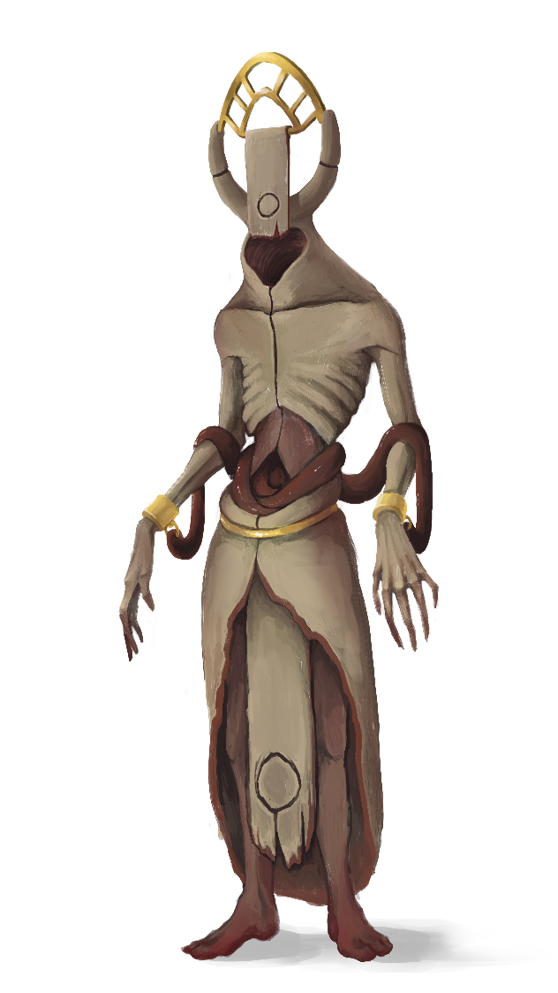Fleshcrafter Priests

Fleshcrafter Priests are immortal liches that represent the remains of humanity. They control and reshape fields of mindless wailing flesh. They have achieved complete mastery of biomancy and effortlessly reshape themselves and their beasts.

Mechanically, the Fleshcrafter Priests operate by remaking their units mid-game. Each Flesh Golem is an expensive, yet highly specialized monster and being able to dynamically reform and restore your army gives them a very high degree of flexibility. Rather than selecting specific units, each unit is built and selected. This allows for any model to function as a WYSIWYG unit. A Fleshcrafter force can be anything from two to ten models, though most will average four to six models.

Shroomin

Shroomin are a faction of mushroom people. Their units are cheap and can easily bypass damage mitigation. Though they die easily, Shroomin return at the end of the next round if the poison cloud they leave behind isn’t absorbed by an enemy. Each Shroomin model forces the enemy into a lose-lose decision. They have access to multiple kinds of poisons, including debuffs, damage effects, mind control, and spawning spores. Their primary caster unit, the Shaman, can create and enhance clouds. You can easily create and clog up choke points via clouds and good positioning.

Hive Courts

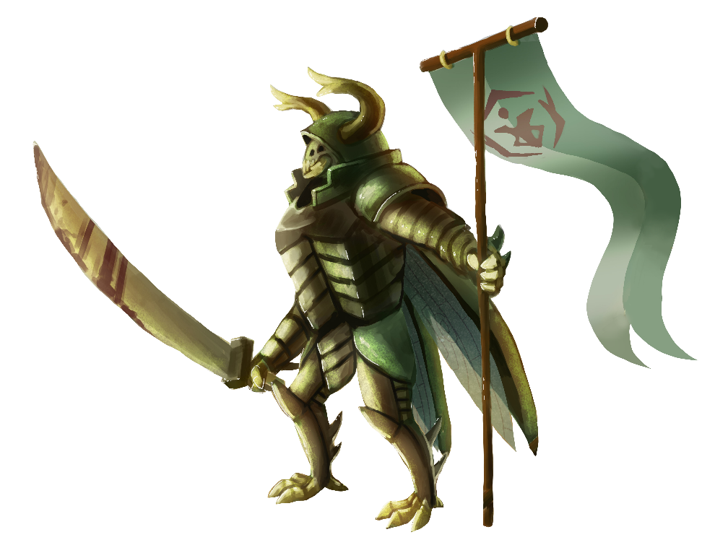 The Hive Courts are a race of powerful insect creatures. They are an extremely honorable culture. While almost certainly outnumbered, no other army has better units for the points than the Hive Courts. They can supplement their low numbers with the use of the Royal Decree ability, which allows the Royal Emissary to let other units take bonus actions out of turn.

The Beetle Knights of the Hive Courts have little in the way of spells or tricks available to them; however, their special abilities allow them to ignore penalties. They are exclusively a melee army. They also have some of the fastest attack speeds in the game. They are a very forgiving force for new players, since most of their abilities are passive bonuses. If you want giant monsters or high-powered unstoppable knights, Hive Courts are for you.

Arcanum

Arcanum is a faction of living magic. They are primal elemental spirits that can teleport and reshape themselves. Their lords can summon in more elementals mid-fight. Arcanum forces are mixed between melee and ranged. Each type of elemental has its own strengths and weaknesses. Additionally, all elementals can reshape themselves and get movement bonuses when moving to a spot with their same element. They also have access to living spells; unkillable area effects that last for the entire game. With their geomancy spells they can alter the battlefield as well, adding or removing terrain as needed,

Morlocks

Morlocks are cold-blooded mercenaries which specialize in stealthy high-speed hit-and-run warfare. They are tunneling armored creatures who can burrow underground. Their advanced movement and deployment options give them the ability to almost strike first where the opponent last suspects. Morlocks have a low toughness but have high power and can move very fast when burrowed. Their units are also capable of laying mines to deny territory and creating tunnels and shortcuts to cross the map in a single turn. 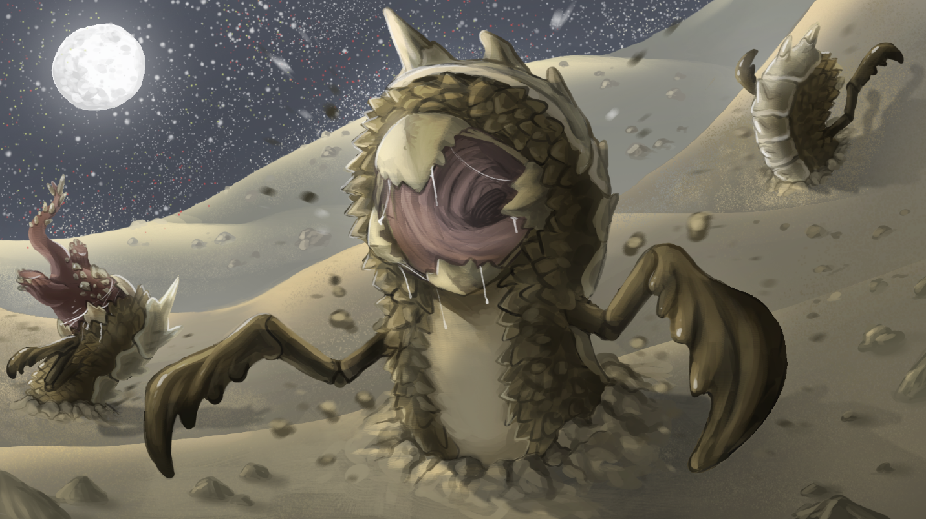

Verdant Horizon

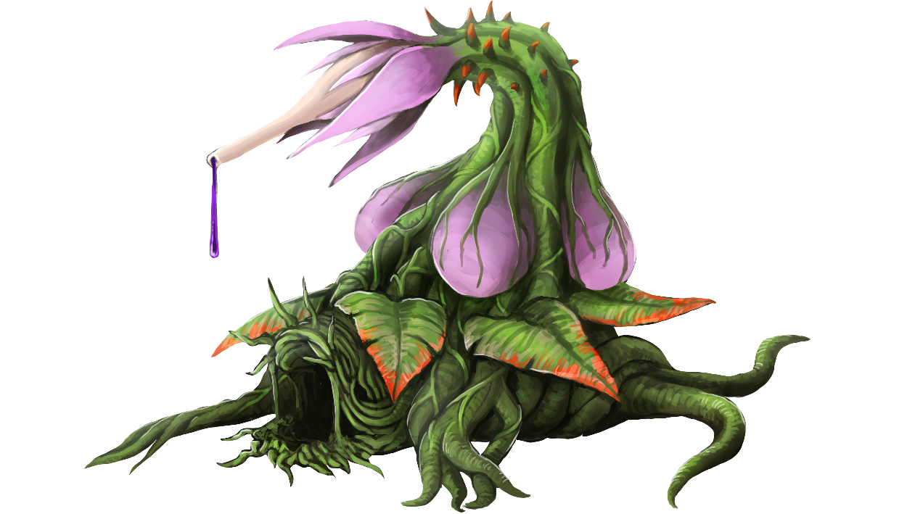Verdant Horizon is an endless tide of overgrowth. It is an enormous single plant organism growing as far as it can. They are a primarily ranged force which focuses on bogging the enemy down with cheap expendable ranged units. The Verdant Horizon models all possess the Seed ability, which allows them to bank up actions and spawn new copies of themselves. In this way, your army can rapidly set up stalwart defensive positions. Each plant has minor passive healing while it is rooted in the ground, and the plants can spread out and mitigate damage through their root networks. No faction has more models than Verdant Horizon, so if you like guns or horde armies consider them.